

Publishing Documents

ST10084349, ST10084286, ST10084726



November 11, 2023

Giggle Gang

# Proof Of Submission to Google Play Console

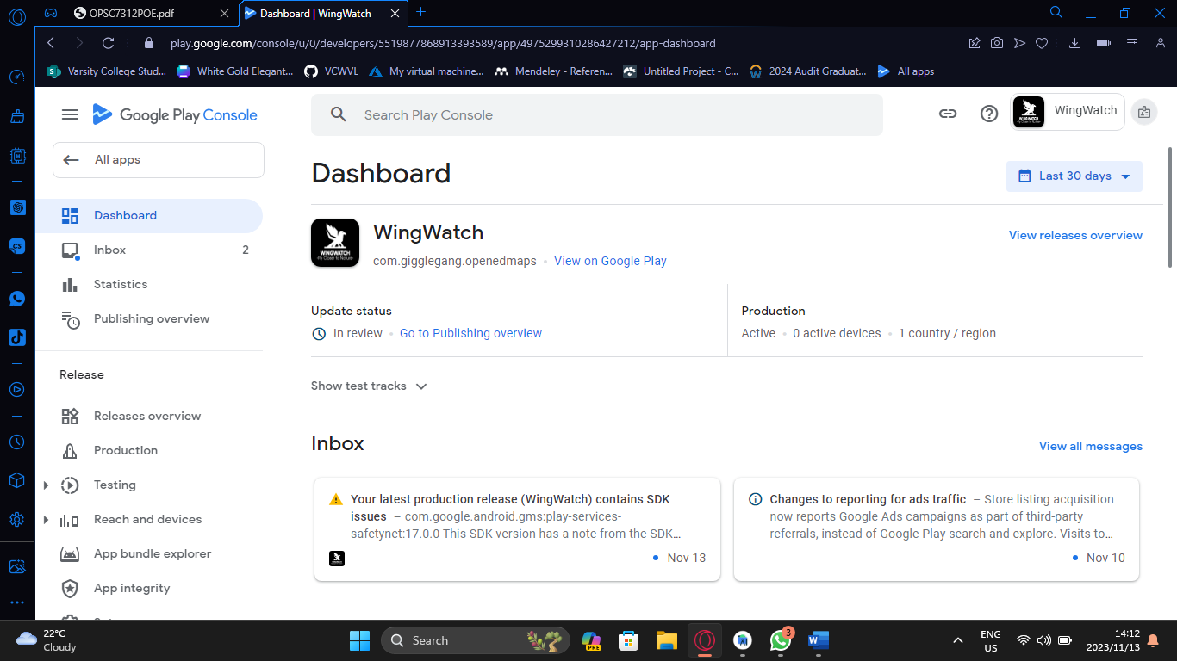

# Creation of APK/App Bundle

